**Web Application Development Plan**

**1. Consider Usage of Scrum Framework and You as a Scrum Master**

I would implement the Scrum framework, facilitating sprint planning, daily stand-ups, sprint reviews, and retrospectives. As the Scrum Master, I would ensure the team follows Agile practices and removes any obstacles.

**2. How Many Sprints You Think You Would Need to Finish the Project**

I estimate that the project will take 4 sprints, each lasting two weeks.

**3. What Management Program Could You Use?**

We would use **Jira** for task management, sprint planning, and tracking progress.

**4. How Would You Send the Collected Data to a Database in the Cloud**

Collected data will be sent to a cloud database (e.g., AWS RDS) using a secure connection. We will handle incoming data through API endpoints, validate it, and use an ORM (e.g., SQLAlchemy) to store it in the database.

**5. Show the Plan Using Gantt Chart**

The project timeline is shown below:

|  |  |  |  |  |  |  |  |  |
| --- | --- | --- | --- | --- | --- | --- | --- | --- |
| Task | Week 1 | Week 2 | Week 3 | Week 4 | Week 5 | Week 6 | Week 7 | Week 8 |
| Project setup | X | X |  |  |  |  |  |  |
| Requirements Gathering | X | X |  |  |  |  |  |  |
| UI Design | X | X |  |  |  |  |  |  |
| Basic Project Structure | X | X |  |  |  |  |  |  |
| User Authentication |  |  | X | X |  |  |  |  |
| File Upload |  |  | X | X |  |  |  |  |
| Data Validation |  |  | X | X |  |  |  |  |
| Data Visualization |  |  |  |  | X | X |  |  |
| Graph Storage |  |  |  |  | X | X |  |  |
| Testing |  |  |  |  |  |  | X | X |
| Deployment |  |  |  |  |  |  | X | X |
| Documentation |  |  |  |  |  |  | X | X |
| Final Review and Adjustments |  |  |  |  |  |  | X | X |

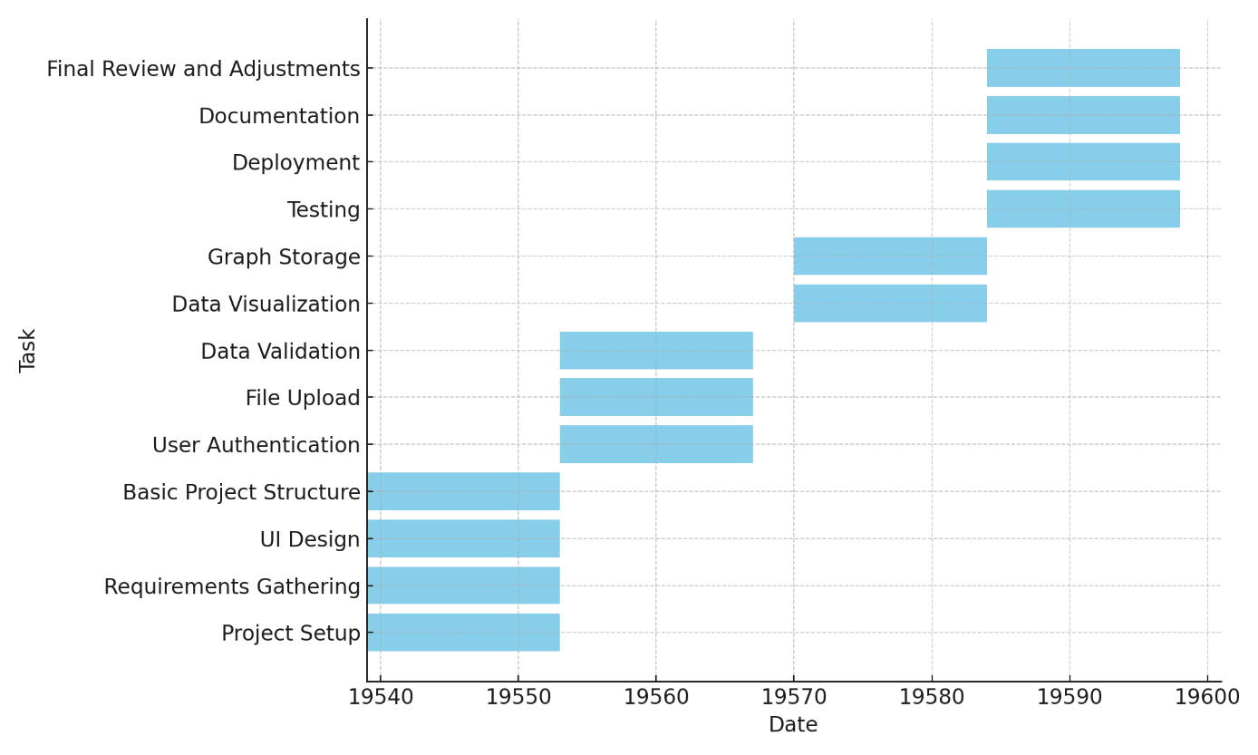**6. present the results in the form of tables and charts**